IFP-ANPK-TOOL – Allows you to create and edit IFP and DAT cutscene files.

Installation:
Place the GTA_Tools and Startup folders in the Scripts folder (3dsMax8\Scripts).
Launch 3dsMax, find “IFP-ANPK-TOOL” in the Utilities panel.

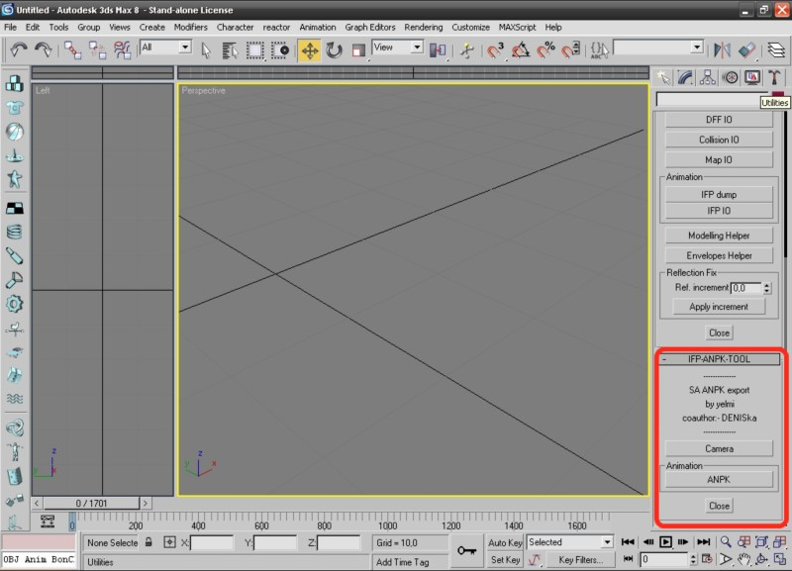
Button “Camera” - launches SetCamera.ms.

“ANPK” button - launches IFP_ANPK.ms.

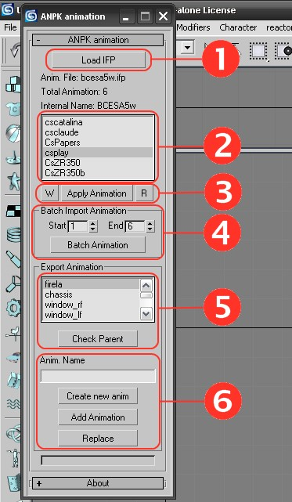
IFP_ANPK.ms
– script for recording and editing IFP cutscene files.

Allows you to create a new IFP file, add animation to the IFP file and replace the animation.
It is possible to load animation for actors (skeletal animation) and objects (cars and other objects), and also record animation of objects and actors. Under no circumstances should you attempt to edit IFP cutscene files that have been processed by the GTA_IFP_IO.ms script. The GTA_IFP_IO.ms script does not correctly record the end-of-file offset.

Button “Load IFP” - load the IFP cutscene file. (Fig. 1) List of animations in the IFP file (Fig. 1. 2)

Button “M” - write down the initial coordinates of the object (Fig. 1. 3)

Button “Apply Animation” - assign animation to an object (Fig. 1. 3)

Button “R” - cancel the assigned animation (Fig. 1. 3)

“Batch Import Animation” - assign more than one animation; it will work only with animations for objects or only for actors. For example, it will load the cscatalina and csclaude animations for the actor, but will not assign CsPapers. That is, it won't work assign the animation of the object to the actor model. Useful in cases where you need to glue several animations into one. (Fig. 1. 4)

“Export Animation” - a group of buttons for recording, adding and overwriting animation. In the input field “Anim. Name" we write the name of the animation; as a rule, this name coincides with the name of the DFF file. (Fig. 1. 6)

The “Check Parent” button (Fig. 1. 5) is needed so that the script knows what animation to record, skeletal or animation of objects. When recording a skeletal animation, the list of objects above the button is not available. This list of objects is only needed to record the animation of Vice City objects. Some VC objects do not participate in animation; for this purpose, it is possible to select the desired object, which should be first (main). As a rule, for SA objects you do not need to touch this list.

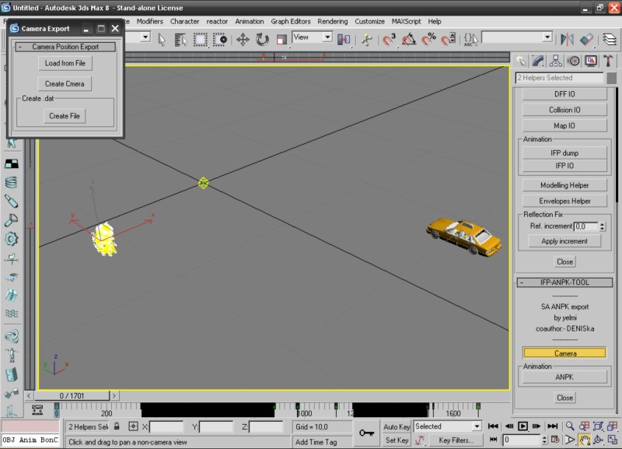
SetCamera.ms – the script allows you to create a cutscene DAT file. (fig2)

Let me remind you that this file contains camera data. You can use a ready-made DAT file by loading it with the “Load from File” button. In this case, a camera will be created with all the key frames. Or create a new camera by clicking the “Create Camera” button. Button “Create File” - Create a DAT file. A new file will be created with all camera settings.

How it all works.

Launch 3dsMax, using the GTA_IFP_IO.ms script, load the DFF file of the model (actor, object) you need.
The GTA_IFP_IO.ms script can be closed, we won’t need it for now.
Launch IFP_ANPK.ms.
Open (“Load IFP”) the IFP file, for example, bhill1.ifp.
Select our model and click the “Apply Animation” button.
We assigned our actor model the animation cskendl. Now let's try to create a new IFP file.
Select our model, click the “Check Parent” button and in the “Anim. Name" enter the name of our animation.
Let's say we loaded the csplay.dff model. We write in the csplay field and click the “Create new anim” button.
In the window that appears, write the name of the new IFP file. The file name must have more than 4 but less than 8 letters.
A new file has been created and csplay will appear in the list of animations (LANPK.jpg. 2).

Add animation:

Select our model, click the “Check Parent” button and in the “Anim. Name" enter the name of our animation.
Click the “Add Animation” button.

Replace/change animation:

In the list of animations, select the one that you want to overwrite. (LANPK.jpg.2)
Select our model, click the “Check Parent” button and click the “Replace” button.

by yelmi http://yelmi.com/
coauthor:- DENISka
Used code GTA_IFP_IO.ms by Kam

